Te Hoe Hōkai Pakihi

Department of Business and Digital Technologies

Bachelor of Information and Communication Technologies

Graduate Diploma in Information and Communication Technologies

**Assessment Three** **Portfolio**

Advancing Programming BCDE321

Semester Two, 2022

Due date: Monday, 9 January 2023

Time: 9:00am

Instructions:

This is an INDIVIDUAL Assessment. Each student must work on their own DIFFERENT program.

Students are responsible for obtaining all necessary resources including software and packages for completing this assessment.

|  |  |  |
| --- | --- | --- |
| **PART** | **TOPIC** | **MARKS** |
| A | Apply Design Patterns and Refactoring Process | 50 |
| B | Evaluation and Discussion | 50 |
| **TOTAL MARKS:** |  | **100** |

Student Name/ID ...Jared Ireland - 99170449............

*If a learner needs to apply for an extension, they can do so by completing the extension request form (*[*app505m-extension-of-time-application.pdf*](https://www.ara.ac.nz/siteassets/documents---home/about-us/policies/general-academic-policies/app505m-extension-of-time-application.pdf)*). Extension requests must be submitted to the lecturer prior to the assessment due date.*

*If an assessment is handed in late without an approved extension, a penalty of 10% per day will apply, up to a maximum of 50%. If an assessment is received more than five days after the due date without an approved extension, it will not be marked. Should a learner wish to appeal any decisions, they may do so in writing to the Head of Department within ten days of receiving the decision.*

This assessment is worth 50% of the marks out of the total of 100 for the whole course. To pass this course, students must gain an average of at least 50% across all assessments, and gain at least 50% in Assessment 3.

This paper has four (4) pages including the cover sheet.

## Learning Outcome Assessed in this assignment. Learning Outcome Three:

Apply knowledge of design patterns to evaluate the effectiveness of software implementation.

# REQUIREMENTS FOR SUBMISSION

After you complete this assessment,

1. Please compress all your work of Part A together, which includes your target program of Assessment 2, your program to Part A and your filled shelf-marking sheet, into a single .zip file and then submit it to the drop box of Part A at the course Moodle site.
2. Please put your work of Part B in a single MS Word .docx file and then submit it to the TurnItIn drop box of Part B at the course Moodle site.

Note that your **filled self-marking sheet** needs to indicate how many marks you think that you can get for each part listed in the marking guide provided. **No marks** may be given if you do not submit your filled self-marking sheet.

Marks will be awarded based on correctness.

# PART A TOTAL MARKS: 50 MARKS

## Apply Design Patterns and Refactoring Process

Using Luc Roghi's Assignment 2 code

Both the GitHub and Moodle versions of my own code seemed to have been corrupted - set PyCharm into a forever loading loop and using Notepad++ or VSCode would open up blank or wingdings files

Looking through Luc's initial code from Assignment Two I have found that there are at least two possible instances where Design Patterns can be applied:

Abstract Factory - Applied to the way Luc makes the Dev and Item cards

Strategy - Applied to converting from Luc's Database to Game

# TASKS:

1. Identifying the target block of code with design problems, which intends to be modified in your target solution of Assessment 2 (3 * N marks)
   1. The locations (i.e., code reference) of the target block of code (1 * N marks)
      * Strategy:
        + game.py - line 14
        + game_data.py - line 110
        + game_data.py - line 222-229
        + Creation of:
          - AbstractConvert
          - CardMaker
          - ConvertDevCards
          - ConvertItems
          - ConvertMaptiles
      * Abstract Factory:
   2. The (before-design-pattern) class diagram of the target block of code (2 * N marks)

See Next Page for Pre-Design Pattern UML of all Code – Both Design Patterns only effect Game.py and Game_Data.py as seen highlighted in Red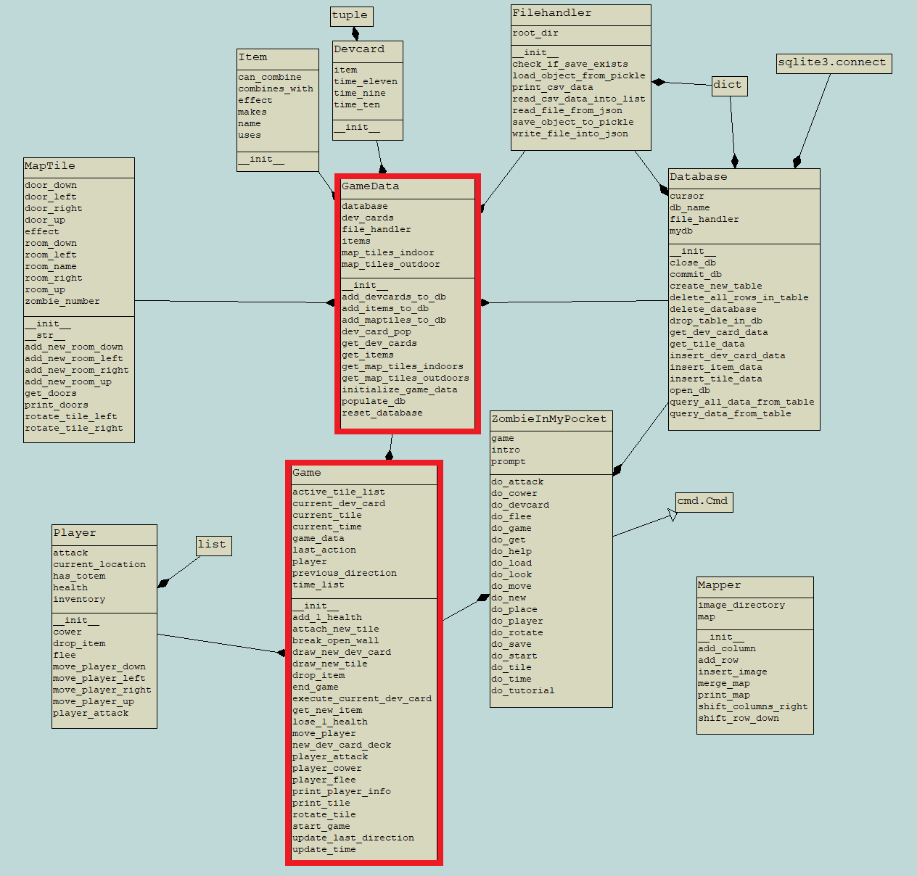

1. Development of testing code (4 * N marks)
   1. Developing a set of testing code for all observable external behaviours of the target block of code in your target solution of Assessment 2. All tests should be able to be triggered through running a single Python file. And your testing code developed needs to pass PEP8 check. (2 * N marks)
      * With the PEP8 Package installed majority of checks for PEP8 are auto checked – there may be some manual checking such as file names
      * Testing files to be created: test_game_data.py
   2. Using coverage package to generate the HTML-version report to demonstrate your developed testing code has **100% branch coverage** for the target block of code (2 * N marks)
2. Design (3 * N marks)
   1. The name of the design pattern, which you intend to apply into the target block of code identified (1 * N marks)
   2. The (after-design-pattern) class diagram of the target block of code after your proposed modification. All the components in the corresponding design pattern structure stated in our design pattern textbook must be explicitly labelled in your (after-design-pattern) class diagram. (2 * N marks)
3. Refactoring by design patterns (11 * N marks)
   1. Applying the design pattern proposed into the target block of code identified. Your solution needs to pass PEP8 check. (10 * N marks)
   2. Version control via an online repository (1 * N marks)
4. Evaluation (4 * N marks)
   1. Demonstrating that the refactored code has the same **observable external behaviours of the original target code** by passing the **same (or updated)** set of tests developed at Task 2 above (2 * N marks)
   2. Using coverage package to generate the HTML-version report to demonstrate that the same (or updated) set of tests can still have **100% branch coverage** for the refactored code. (2 * N marks)

# PART B TOTAL MARKS: 50 MARKS

**Evaluation and Discussion**

# TASKS:

Evaluate and discuss how your solution in Part A of this assessment effectively uses the **N**

design patterns to solve the design problems existing in your target solution of Assessment 2.

***Please note*** that ***15*** different knowledge points are expected to be referred to and explained with your code in your answer of Part B. Please use only one of the **N** design patterns applied in your solution for Part A when you explain a single knowledge point. Using two of the design patterns to explain a same knowledge point will not double up the marks for that knowledge point.

Please provide your answers in a concise fashion and be straight to the point. The style of bullet points is fine.

## Suggestions

To address a single knowledge point with your code, 4 things should be addressed:

1. The knowledge point, which guides you to find the solution to the problem; It is expected to be directly found and quoted from our design pattern textbook. Please note that a knowledge point should be a sentence at least. It is also wrong to quotes paragraphs in your answer as well.
2. The problem, which describes a design problem in your target solution of Assessment 2; Expect to see code snapshots plus description/explanation.
3. The solution statement, which describes your solution to the design problem identified above. The solution can be a part or one of the design patterns applied in Part A. Expect to see code snapshots plus description/explanation.
4. Effectiveness, which is to analyse how your solution effectively solves the design problem by using the knowledge point.

Your answers for Items b) - d) MUST be specified/ customized for the particular situation of the code involved, i.e., do not just give generic statements. Generic statements can be easily found in textbooks and internet and not be able to demonstrate your understanding at all.